The longest-running and most prestigious nature photography competition in the world returns to the ROM for the 11th year in a row.
As Clear as Crystal was taken by Jason Gulley (USA). Jason has photographed many manatee mother-and-calf pairs. Here in the Crystal River, an algal bloom caused by agricultural runoff led to a decline in the eelgrass beds that the manatees eat. The local community acted, restoring the habitat and improving water quality, resulting in more manatees than ever being recorded in the winter of 2022/2023. The calf’s expression combined with this hopeful story have made this one of Jason’s favourite photos.

The exhibition's stunning images allow visitors to experience nature in vivid detail and get up close to some of the world's most extraordinary species, the lives they live, and the challenges they face.

Whether you’re a nature lover, aspiring photographer, or simply love a perfectly captured moment, you will appreciate the talent and technical expertise required to photograph such rare and surprising glimpses of the diverse life on this planet.

Use this Gallery Trail to explore the exhibition. Choose photos that interest and inspire you.
Please:
- Remember you are sharing this space with others.
- Be aware of your surroundings and the noise level as you work.
- Make sure not to block access to the photos.

Calling all photographers ages 13-17!
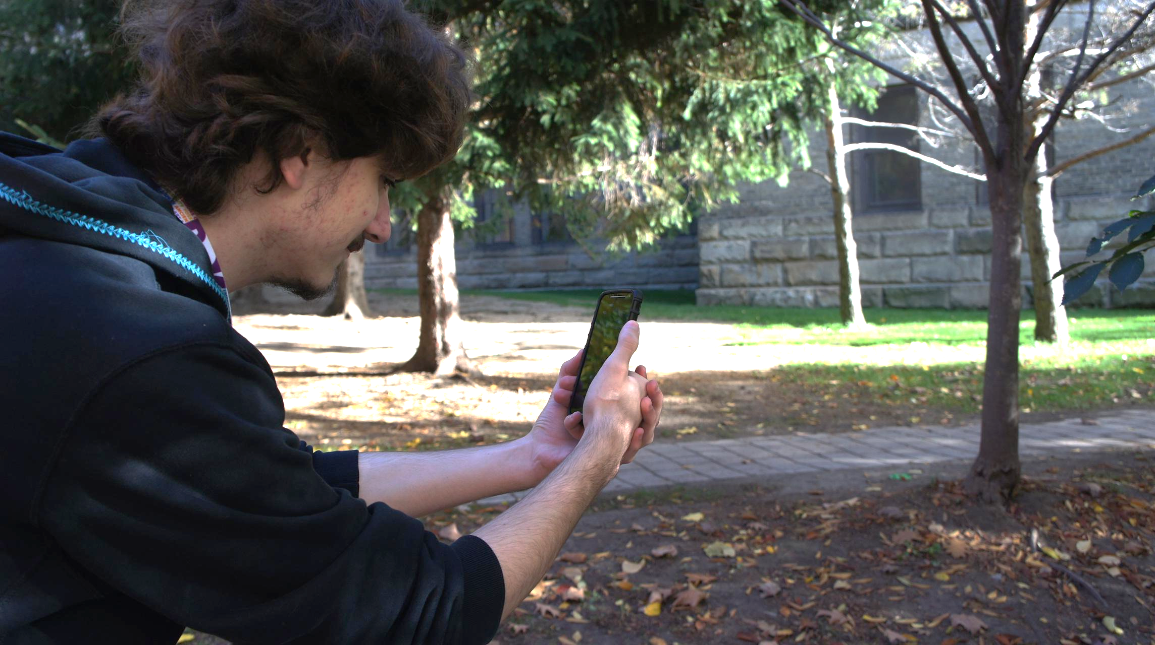
From December 21, 2024 to February 21, 2025, share your wildlife photos from an unlocked Instagram account and include @ROMtoronto and #ROMwpyJR, and you could win the
Grand Prize:

- Sony Alpha ZV-E10 camera courtesy of Henry’s
- One-year ROM Curator’s Circle membership
- Have your work displayed in the museum!

Plus 2 Honourable Mention prizes of a 1-year family membership.

See rom.on.ca/contest for more information.
Art of Photography

How the elements of a photograph are organized can make the difference between a snapshot and a work of art. Photographers use many different techniques to compose an eye-catching photo that will capture the viewer’s attention and create a memorable image.
- Learn about three compositional techniques below.
- Choose a photograph that uses at least one of these techniques.
- Sketch the photo in the box and answer the questions.
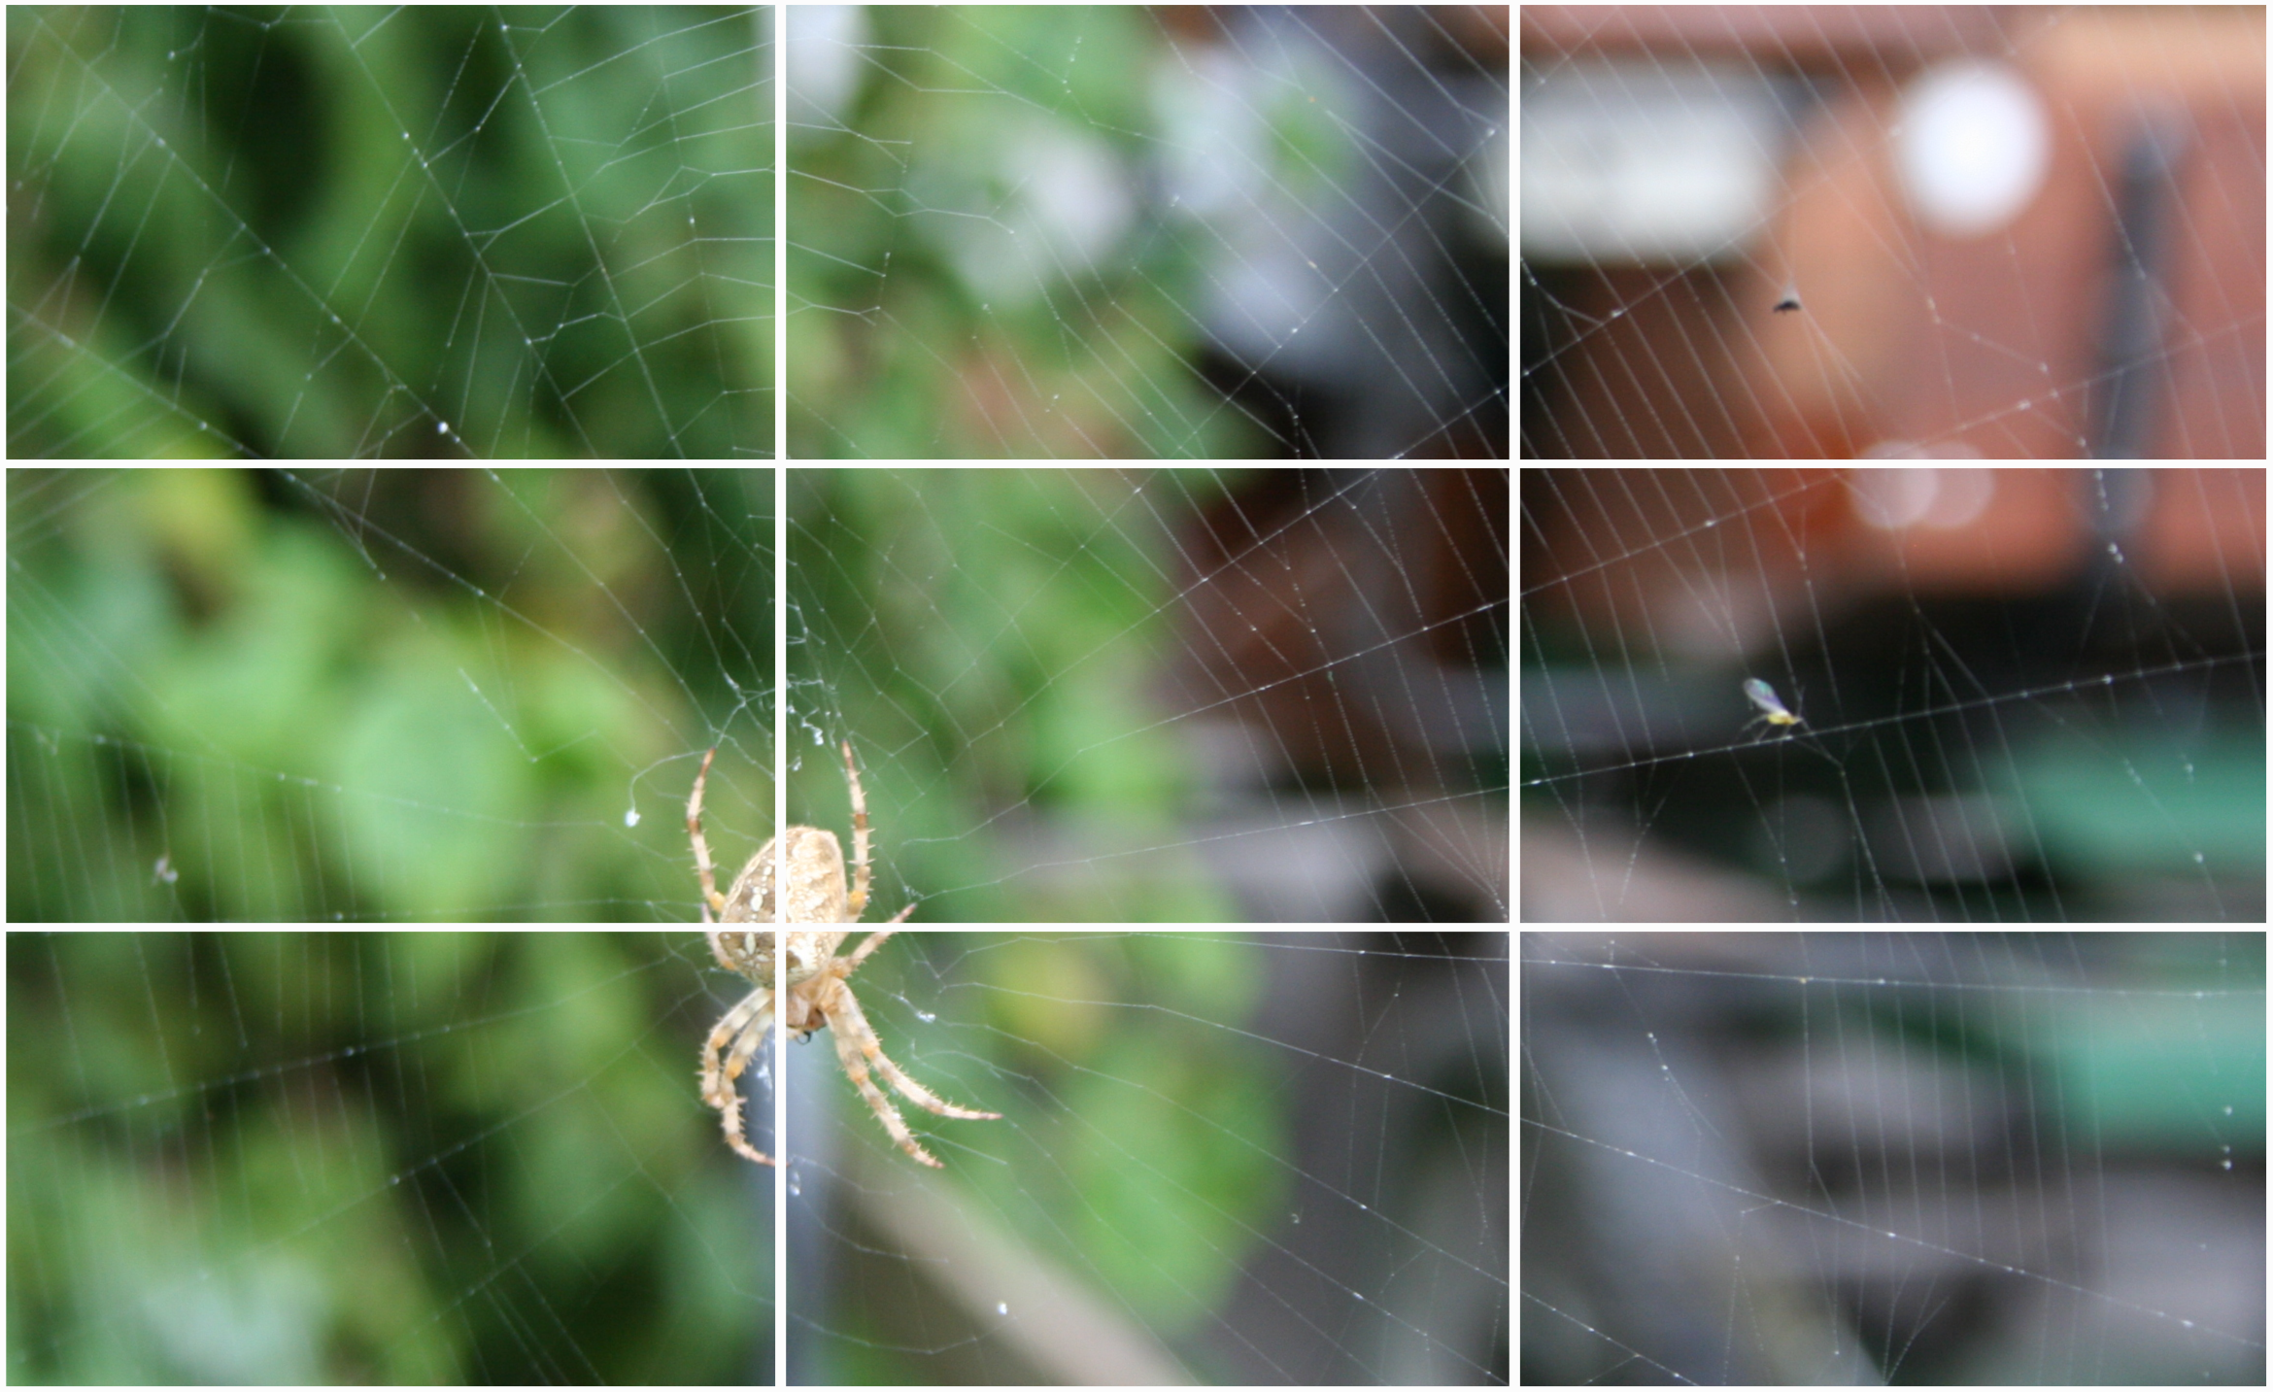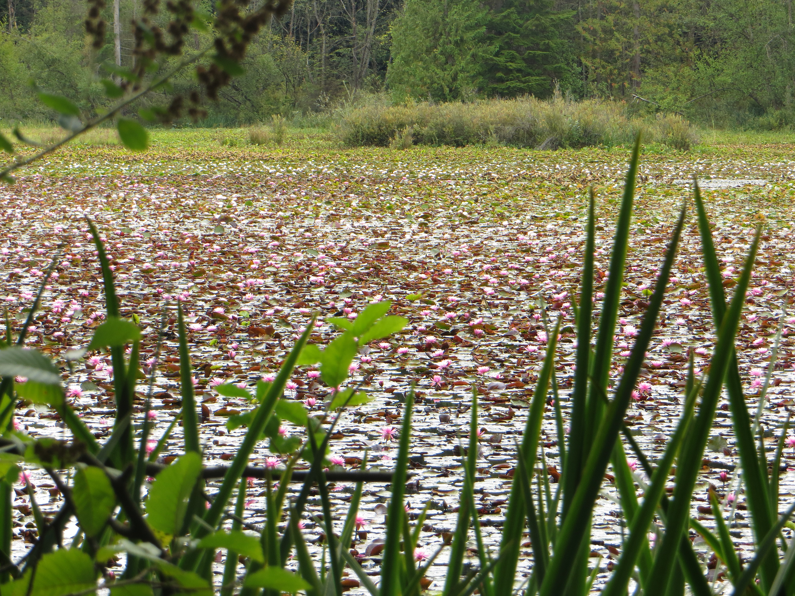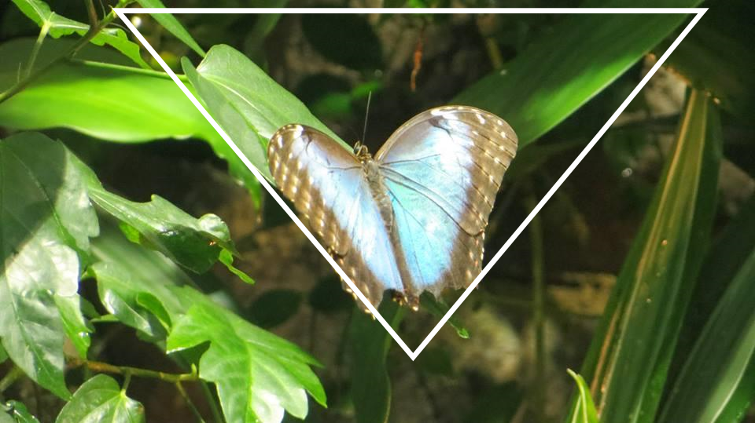
Rule of Thirds Creating Depth Triangle Rule
Photos are two-dimensional snapshots of a three-dimensional world. To create depth in a photo, you include objects in the foreground, middle ground, and background. The human eye naturally recognizes these layers, separates them out, and creates an understanding of depth.

Triangles can be very useful shapes in creating feelings of stability, aggression, instability, and more in a photograph. For example, putting the base of a triangle along the top of the photo and the apex at the bottom can create a feeling of instability.

Divide an image into thirds, both horizontally and vertically. When the subject of the photo falls close to or along one of these lines, the photo tends to look more pleasing and natural to the eye.

Title:

Photographer:
Compositional technique(s) used:

What captured your attention about this photograph and why?

Once you leave the exhibition, check out the nature displays in Life in Crisis: the Schad Gallery of Biodiversity on Level 2. Find a suitable background and act out a recreation of your favourite photo.

Your teacher can share the photo with @ROMtoronto #ROMLearning!

The Wild

A picture is worth a thousand words! One photo can tell us a lot about its wild subject: where and how it lives, what it eats, how it hides, how it communicates, what its family is like, how it adapts, or what role it plays in its ecosystem.
Choose a photo and describe the following:

Title:
Photographer:
Look closely. Describe the wild subject and its environment based only on your observations.

Choose a photo that tells an interesting story. Figure out what the photographer did and what tools the photographer used to capture this story.
Think about:
- What lighting did the photographer use?  - What time of day was the photo taken?  - What research would the photographer have to do to capture the photo?  - What did the photographer need to know about the subject before taking the photo? | - Where was the photographer positioned? (Low to the ground? Eye level? From above?)  - Did the photographer need a special lens? (Telephoto or wide angle?)  - How long did the photographer wait to get the photo?  - What risks were involved in taking the photo?

BACK IN CLASS:
Imagine that you are the photographer. Write a diary entry about the day you captured this photo. You can write your diary as a written text, a comic, a video blog, or another way that works best for you!

Indigenous Stories
Some Indigenous Nations look to animals and the natural world to observe lessons and ways in which we can live a good life. Throughout the exhibition, you’ll find Indigenous stories about the subjects of some photos.
Choose one story, and explain what you learned from it:

Take Action
Photographs are powerful tools that can be used to call attention to serious conservation issues. We are all caretakers of our planet, and raising public awareness of issues like the ones highlighted in this exhibition is a key step to the conservation and protection of wildlife and natural environments.
Choose the photo with a conservation theme that creates the strongest impression on you and identify the following:

Title:
Photographer:
Describe the conservation issue:

Imagine you have jumped into the photo, and take on the role of the wild subject or the environment itself. From your perspective, and using the information on the label to help you, describe what is happening to you and how it affects your way of life. Finish your story back in class.

BACK IN CLASS:
Do additional research on the conservation issue you identified and design a conservation campaign to raise awareness about this issue.
Take photos to support your campaign and share them with us!

@ROMtoronto #ROMLearning
Spread your message in:
- a poster
- a photography exhibition
- a video
- a story
- a social media campaign
- a medium that works best for you!

